

**Ahsanullah University of Science & Technology**

**Department of Computer Science & Engineering**

**Course No. :** CSE 4108

**Course Name :** Artificial Intelligence Lab

**Assignment No. :** 02

**Submitted To :**

Md. Siam Ansary Tonmoy Hossain

Department of CSE, AUST Department of CSE, AUST

**Submitted By:**

Name : Sanjida Akter Ishita

ID No. : 170204089

Session : Fall 2020

Section : B

Lab group : B2

**Date of Submission:** July 24, 2021

**QUESTION:** Implement K-means Clustering and K-nearest Neighbor Classifier without using Scikit-learn.

**ANSWER:** Implementing K-means clustering using Scikit-learn is easy. But in this assignment we have to implement this without using any library function of Scikit-learn.

**K-means Clustering**

Code in python

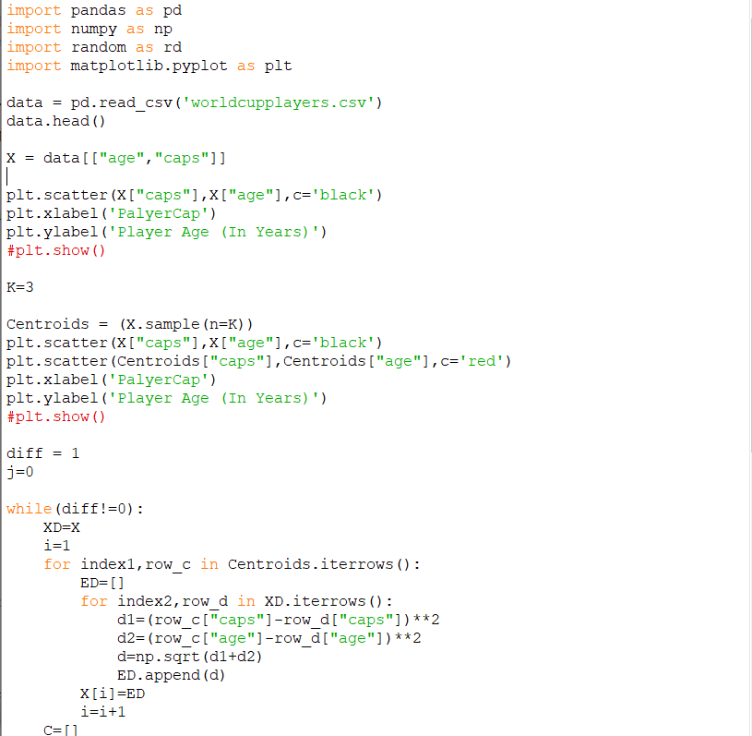

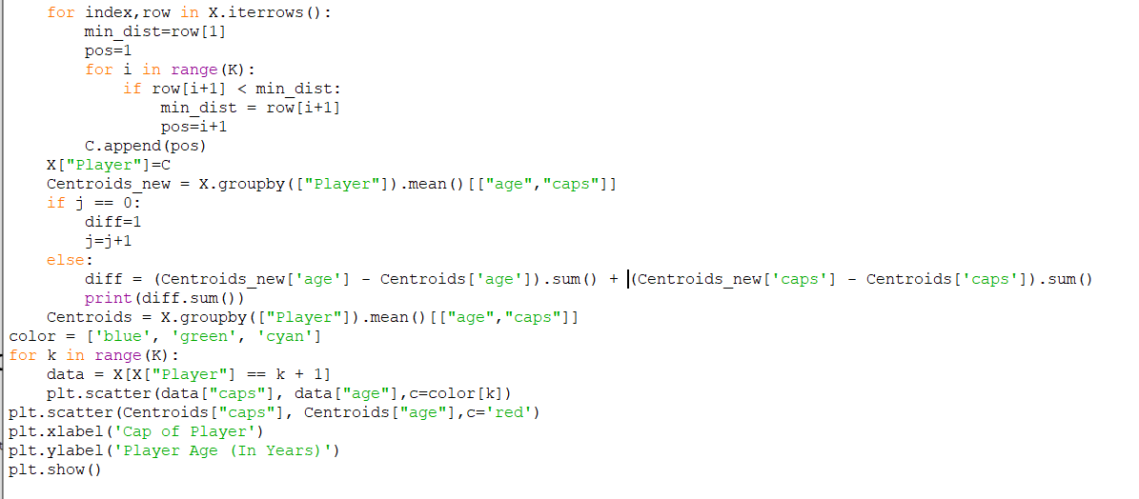

**Dataset**

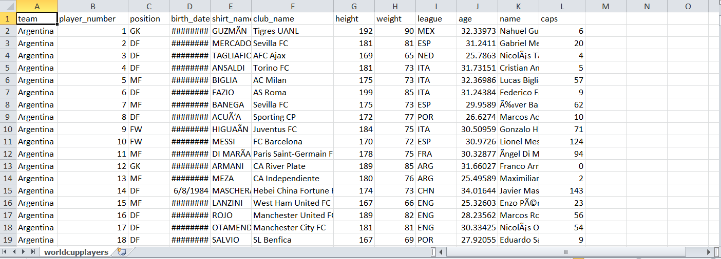

Figure 1: A part of worldcupplayers.csv. From this dataset only two columns are taken, named age and caps.

**Output:**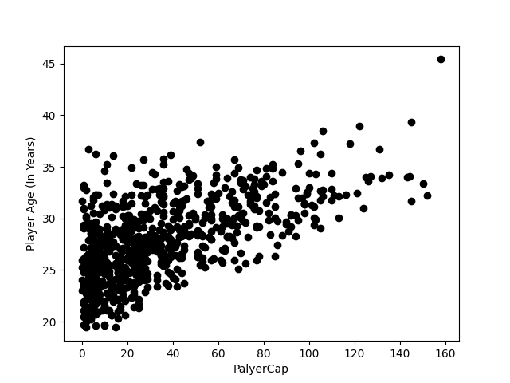

Figure 2 : Before Clustering

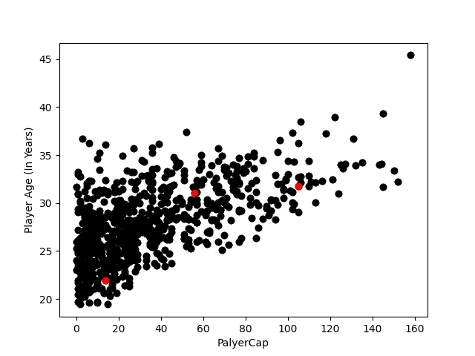

Figure 3 : Randomly finding 3 centroids

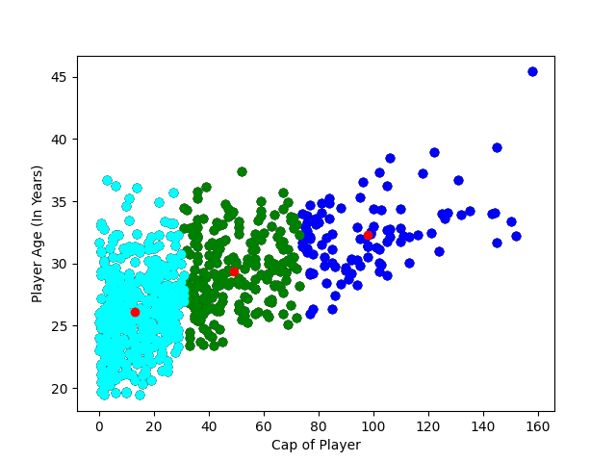

Figure 4 : After Clustering

**K-nearest Neighbor**

Here I have to implement K-nearest Neighbor without using library function of Scikit-learn. With library functions it would be easy. But I have to choose other way for implementing it. Here are the code and output

**Python Code**

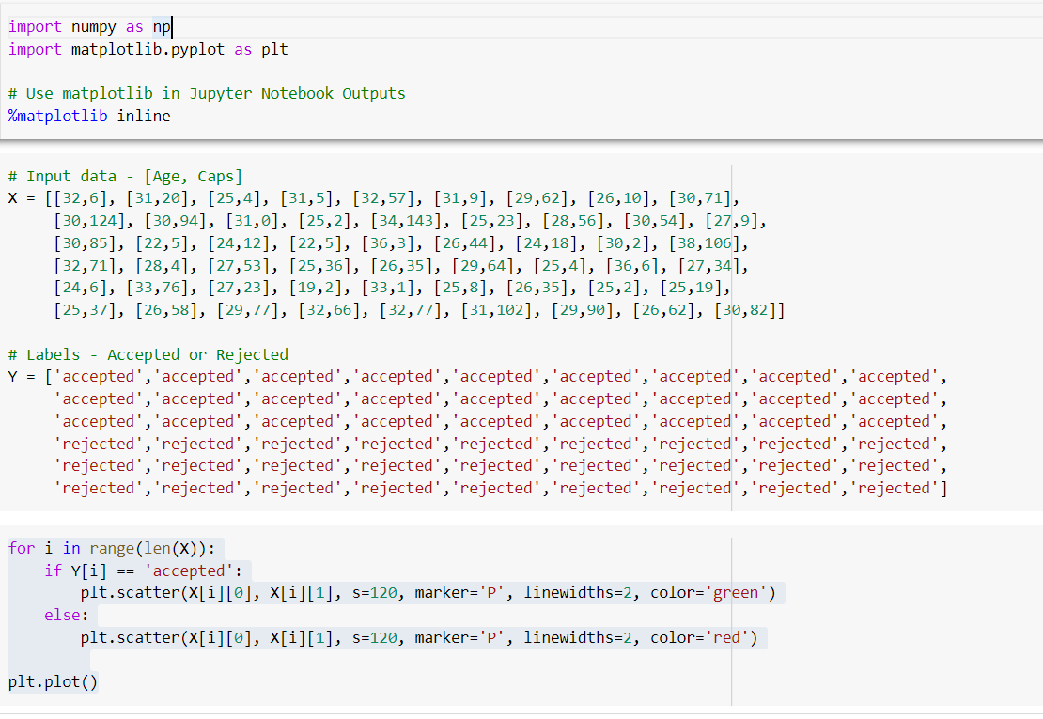

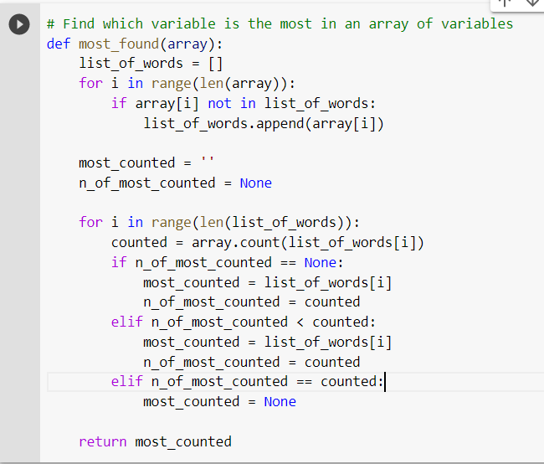

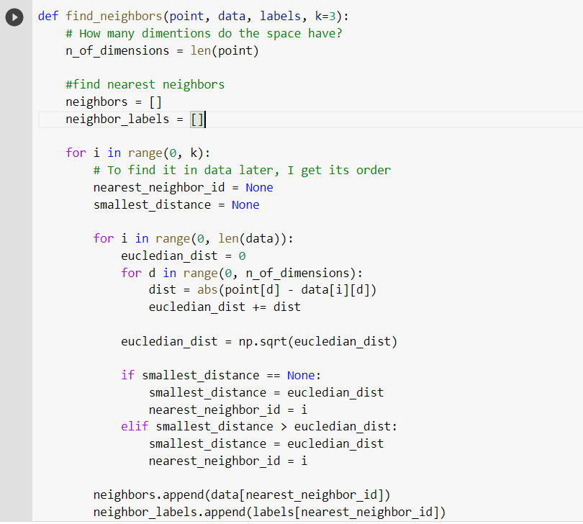

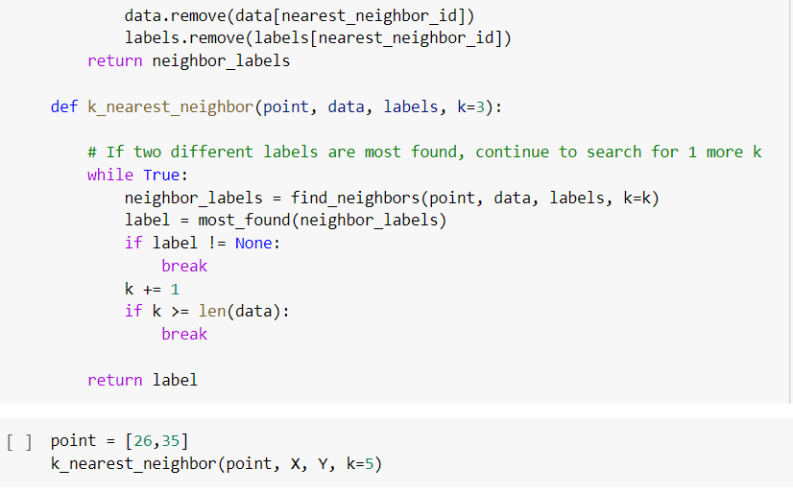

**Output**

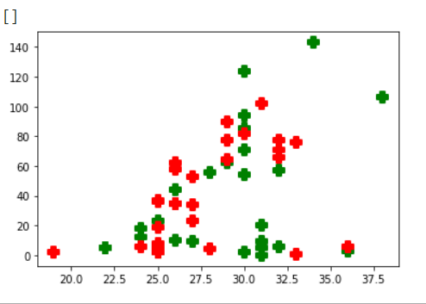 Figure 5: Plotting dataset in a graph after using matplotlib library

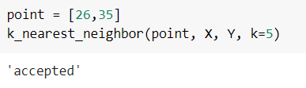

Figure 6: Output `accepted' for input Age 26 and Caps 35